Texas A&M University-Commerce
Voicemail Guide

INTRODUCTION
Telephone User Interface a way to access your messages from any phone, whether internal or external to the campus. This interface allows the control of your voicemail via user options, as well as recording of your greeting messages, consultation and management of your received and sent messages. Graphical User Interface a way to access your messages from your digital or ip phone (only) that allows the control of your voicemail including recording of your greeting messages, configuration, and management of your voicemail messages (not available on analog/single-line phones).

Web Interface a way to access your messages from a browser and allows the control of your voicemail configuration and management of voicemail messages. This option is available for any type phone.

Telephone User Interface (TUI)

How do I access it?
From your multi-line desk phone:
- Press the MAIL key, and then select the voicemail option. You may also press *## to access voicemail.
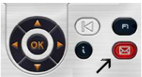
- On the phone screen press the soft key associated with the voice messages feature.
- The first time you access voicemail, enter the default password (12341234). The system will welcome you and ask you to record your name.
- Speak your name and press #.
- Enter a new password. The system confirms which password has been recorded. The password you select must be between 4-8 digits long and should not be something easily guessed such as 111111, 1234, or a birthdate.
From a single-line phone:
- Dial x5003. Or you may press *##.
- Enter your personal voicemail box number (your 4 digit phone extension).
- Enter your password.
  - The first time you access voicemail, enter the default password (12341234). The system will welcome you and ask you to record your name.
  - Speak your name and press #.
  - Enter a new password. The system confirms which password has been recorded. The password you select must be between 4-8 digits long and should not be something easily guessed such as 111111, 1234, or a birthdate.

From an off-site phone:
- Dial 903-886-5003.
- Press 1.
- Enter your personal voicemail box number (your 4 digit phone extension).
- Enter your password.
  - The first time you access voicemail, enter the default password (12341234). The system will welcome you and ask you to record your name.
  - Speak your name and press #.
  - Enter a new password. The system confirms which password has been recorded. The password you select must be between 4-8 digits long and should not be something easily guessed such as 111111, 1234, or a birthdate.

To access your voicemail from a campus phone that is not assigned to you:
- Dial x5003. Or you may press *##.
- Press 1.
- Enter your personal voicemail box number (your 4 digit phone extension).
- Enter your password.
  - The first time you access voicemail, enter the default password (12341234). The system will welcome you and ask you to record your name.
  - Speak your name and press #.
  - Enter a new password. The system confirms which password has been recorded. The password you select must be between 4-8 digits long and should not be something easily guessed such as 111111, 1234, or a birthdate.

What can I do with the Telephone User Interface?

Listen to New Messages
Once you access the Telephone User Interface, your new voicemail messages will automatically play. To access archived messages, press 1.

While listening to your messages, you have the following options:
- Pause/resume message – Press 2
- Delete message – Press 7 (if confirmation is required, press 7 again)
- Listen to the next message – Press #
- Reply to message – Press 8, when you finished recording your reply, press #.
- Forward a copy of your message to someone else – Press 6, follow instructions, and when you have finished recording your introduction, press #.

At the end of your message, you have the following options:
- Listen to the message again – Press 11
- Delete the message – Press 7 (if confirmation is required, press 7 again)
- Listen to the next message – Press #
- Reply to the message – Press 8, when you have finished recording your reply press #
- Forward a copy of your message to someone else – Press 6, follow instructions, and when you have finished recording your introduction, press #.

Manage Your Greeting Messages
Types of Greetings:
- Standard – This is the standard greeting that is followed by your name (if you choose to record it). Your voicemail number can be used instead of your name.
- Personal – This is a personal greeting that you have recorded and activated via the Greeting Management Menu or the Web interface. It replaces the standard greeting. You may record additional greetings that are only played to internal callers.
- Alternative – The system allows for 2 additional alternate greetings. This is best used for specific business situations. This greeting is activated by you according to your needs. Once you no longer need to utilize the alternate greeting, you must log into the management menu to make the change.
- Extended Absence – This is a greeting dedicated to situations where you are out of the office for a planned period of time. When an extended absence greeting is activated, callers are explicitly made aware that you may not be able to listen to your voice messages soon. They have to press a key to be able to leave you a message. When this greeting is activated, each time you access your voicemail box, it will remind you that the extended absence greeting is activated. At this stage, you can retain or delete the greeting. If you decide to delete it, the system activates the greeting configuration you had prior to activating the extended absence greeting. The extended absence greeting is automatically activated after it is recorded.

Call Back Sender of a Voicemail
- In the list of messages, select the message of your choice with the navigator keys and press the OK key to display a popup menu. Select Sender callback.
- Your telephone rings. Pick up the phone and wait for the callback phone to respond to your call.

Display the Header of a Voicemail
- In the list of messages, select the message of your choice with the navigator keys and press the OK key to display a popup menu and select Message Header.
- The following information is displayed:
- Calling Number
- Date and time of message
- Length of message
- You can:
- Listen to the message – Select Play
- Delete the message – Select Delete
- Go back to the list of voice messages – Press Back Key
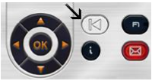

Delete a Voicemail
In the list of messages, select the message of your choice with the navigator keys and press the OK key to display a popup menu and Select Delete. This automatically goes back to the list of remaining messages.

Manage and Configure Greetings
- Once you access voicemail under the GUI, press the Greetings Soft key.
- The list of greetings will pop up. The active greeting is highlighted with an “>”. In the example below, the Personal greeting is active as indicated by the “>”.
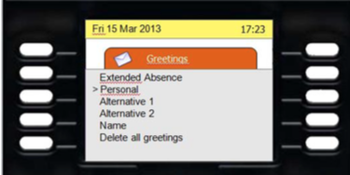
- To delete all greetings, use the soft key next to the delete all greetings option.
- To activate, record, or play a greeting, use the up and down navigator to select the type of greeting you want to activate, play, or record. The selected greeting is highlighted.
- Press the OK key to access the Activate, Record, or Play feature. The play feature is displayed only if a greeting was previously recorded.
- To record a greeting, select the greeting you want to play by choosing OK. Navigate to Record and press OK. You can Start or Exit as needed. While recording, the duration is displayed on the screen. You can stop the recording by pressing the associated soft key.
- Once the recording is stopped, you can:
- Validate the recording (this does not activate the recording) – press Accept
- Go back to the greeting menu without validating the recording – press Exit
- Listen to the recorded greeting – press Play
- Record the message again – press Re-record
- To activate a recording, select the recording you want to activate, press OK, then select Activate and press OK.

Web Interface

How do I access it?
- Open a web browser and go to the following URL – https://otms.tamuc.edu/MyMessaging. You must be on the Texas A&M University – Commerce network or utilizing the VPN client in order to access the web interface. Please contact the help desk if you are unsure as to whether you are on the Texas A&M University-Commerce network or need assistance with the VPN client.
- Enter your AD credentials to login.

What can I do with the Web Interface?

Listen to Voicemail on Computer/Phone
- In the list of messages, click the play button under the PC column to listen to the message on your PC. Or, in the list of messages, click the play button under the Phone column. The rewind, advance, pause, stop and play options are accessible from the web based interface under the phone column.
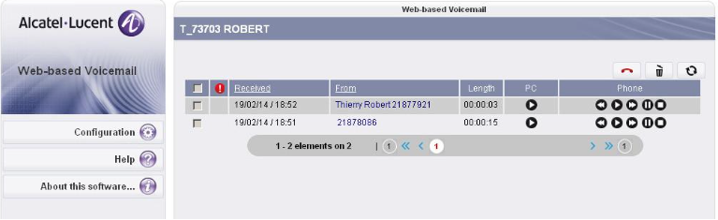
- A popup window will open and ask you if you want to download the message or listen to it. If you choose Listen, the default multimedia players on your computer, will open and you can listen to the message.
- At any time, you can end the voicemail message by selecting the hang up icon.
- To delete messages, select them via the checkbox in the first column and then click the delete icon.

Configure Voicemail Settings
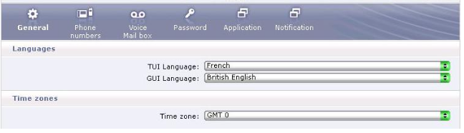
- To configure Telephone User Interface and Graphical User Interface Language options, click Configuration and select the general tab. Pick the language you would like to use in the Telephone User Interface and the Graphical User Interface from the corresponding drop downs. You may also set your time zone on this screen by utilizing the drop down menu to select the appropriate time zone.
- To configure options in the voicemail area, select the voicemail box option.
- In the greetings section you can manage your greetings by selecting the checkbox next to the greeting(s) you want to activate.
- Under voicemail options you can configure additional options by checking the box next to the option. Available options are:
- Option answer only mode – Callers can hear your greeting message but cannot leave messages.
- Option addressing by name – When sending a voice message to another person with a Texas A&M University-Commerce voicemail box, the system can address the message by the intended recipient's mailbox number or name.
- Option automatic reading – When you connect to your voicemail, the system announces the number of unheard messages and then automatically plays them.
- Option confirm message suppression – You are requested to confirm each deletion of a message when you are utilizing the telephone user interface.
- Option personal assistant – A caller has the option to press 1 for an urgent call, 2 to leave a message, 3 to disconnect.
- Option 24 hour mode – this changes the time from a standard 12 hour format to a 24 hour military format for displays and readouts.

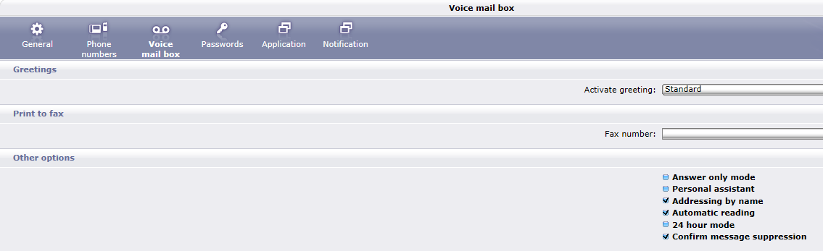

- To configure options in the Notification area, select Notification from the menu. Under this menu you can configure e-mail notifications. To enable e-mail notifications, check the notification mail check box and fill in your email address.
